Firewall Configurations: Basics of firewalls and ufw/iptables in Linux. Creating rules for inbound and outbound traffic. Practical (1 hour): Configure ufw to allow SSH and block other services. Task: Document the configured firewall rules.

Tasks

1. Install ufw on your Linux system (if not already installed) and enable it, then verify its status using the appropriate commands.

ANS:

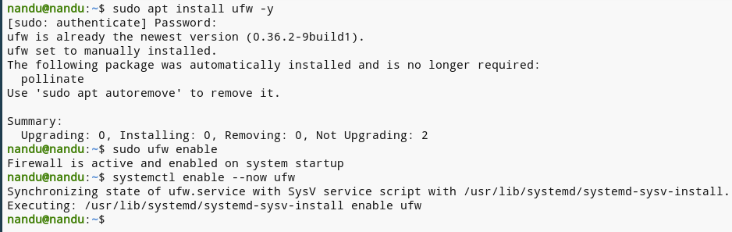

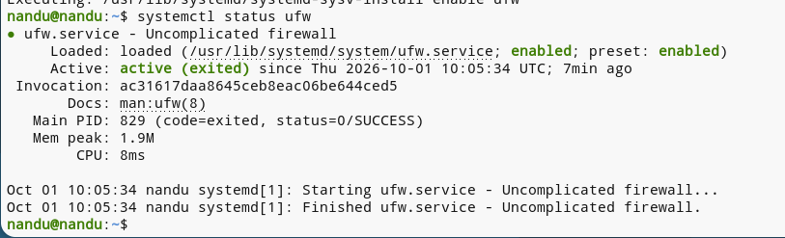

2. Configure ufw to allow incoming SSH connections only on port 22 and block all other incoming connections.

ANS:

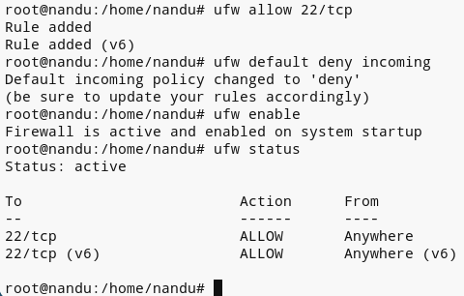

3. Add a rule in ufw to allow outgoing HTTP and HTTPS traffic (ports 80 and 443), but block all other outbound connections. Use 'ufw allow out' and 'ufw deny out' commands to control outbound traffic.

ANS:

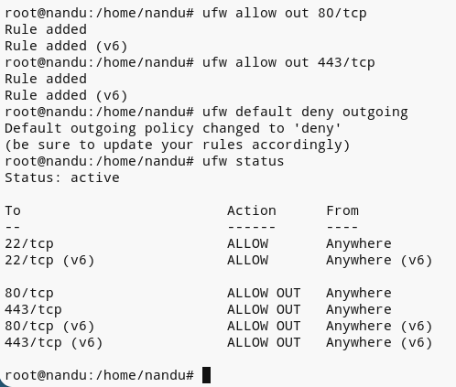

4. List all currently active ufw rules on your system and save the output to a file named firewall_rules.txt.

ANS:

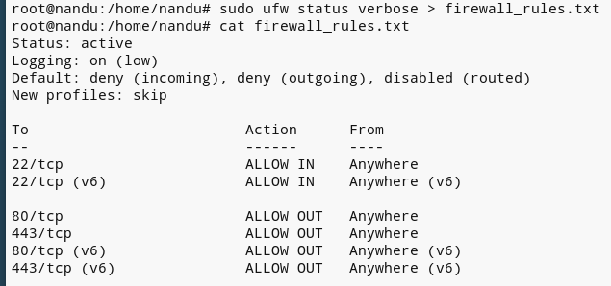

5. Write a short explanation (3-4 lines) describing how your current ufw configuration would impact running a local web server (like a development server for a Zomato-style food delivery app).

ANS:

My current UFW configuration allows only the required ports, while blocking unwanted incoming connections.
So, a local web server can run normally on its allowed port (such as 80, 443, or 3000).
If that port is blocked, the app will work on the same computer but won’t be accessible from other devices on the network.

